HUAWEI Y9 USER MANUAL

Introduction
- Huawei Mobile Y9 is the newest addition in the ever-growing family of mobile phones by Huawei.
- The model of Y9 is another exceptional addition to it.
- With its added feature and adaptability, the device is a noteworthy addition to hands of any professional/novice who wants to buy a phone.
Features
- Huawei Y9 has a 6.5 inch screen, with a metallic, multi-shaded cover of red-blue metallic shaded outer body. It is also available in other shades.
- It has 16 megapixel front camera and two dual-lensed 13-megapixel rear cameramaking a total of the 26 megapixel rear camera.
- The camera uses the artificial intelligence in the photo capturing, making its photography unique in nature.
- It has the android 4.2 Jellybean installed in it.
- The mobile is 17.5 g in its weight and slim in design.
- It has all basic applications, with smart share, and twinning application system.
- It has touch screen and use of smart gesture system that enables it to use an extra layer of security.
- It has phone manger, cleaning app and other relevant phone features making it easy to use by all.

Starting the Phone
- Before starting, find your smart SIM that will connect your mobile with the network and insert it in its jock.
- The cell has the buttons on the left side that starts the cell.
- After starting the phone, type your name and name of your location.
- Adjust the phone clock and backup settings.
- After it, adjust the home screen. The WiFi will be connected automatically by the smart connectivity touch.
- Scan your finger-print and create a smart-lock pattern for your cell by clicking on the lock button on top-left of the screen.
- If you have your email address readily available, log into Gmail account and set-up entire Google account setup.
- By virtue of Google account, the Google Play will start functioning.
- The phone will start with all its features.
- Download your apps, make accounts and personalize your cell even further.
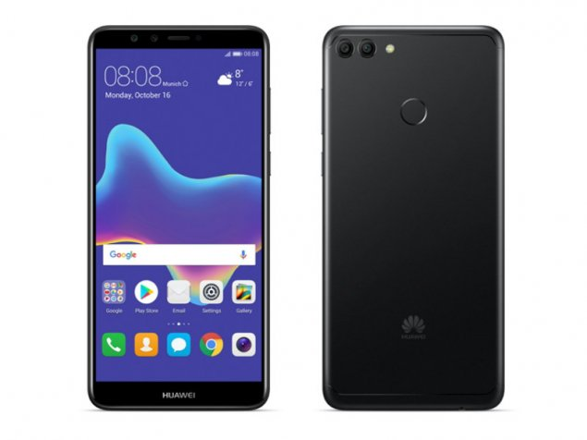
Using the Basic Functions
- Set-up your mobile phone contacts and put a memory card in its slot.
- Save the data in the card by use of the USB lead that can connect it to any computer, or by turning on the Bluetooth that will pair the cell to another Bluetooth device.
- Drag the top-screen for opening the connectivity options and basic utilities (screen brightness, volume adjustment, notifications, location, data-connection, flashlight, hotspot, screen shot, screen recording and other related options)
- Use the dial functions and contacts to call anyone.
- The messaging service is readily available. The cell can send the SMS and MMS readily.
- The Gallery is a place where all the files can be kept and located. Search and look up the files, make folders, rename, edit or delete the files.
- The one-touch optimizer on the home screen will improve the functioning of the cell and clear all un-necessary files.
- The menu option will show all icons of the in-built features of the cell.
- The camera functions are easily availed by clicking on the camera icon on the home screen.
Charging, Media and Backup
- The cell has a USB charger with a USB connection slot.
- The battery takes around 2 hours to be full.
- The Backup and Restore option helps in retention of data.
- It has built-in multimedia functions and apps.
Caution
- Donot use the device near fire or high electricity
- The glass screen is breakable; hence it is to be protected by a cover.
- The mobile should not be kept on charging for more than 8 hours.
- Keep away from water and radiation.
- Keep the mobile neat and clean for longevity (“HUAWEI Y9 2018”)
‌

Works Cited
“HUAWEI Y9 2018.” Huawei.Com, 1 Jan. 2018, https://consumer.huawei.com/bd/support/phones/y9-2018/.

