1.
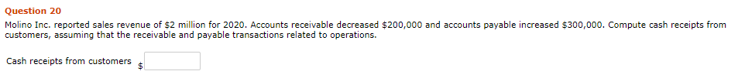
$ 2.2Million
2.
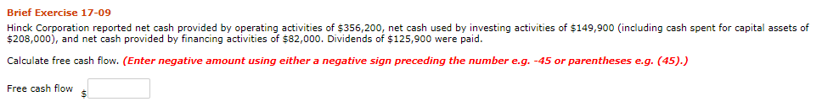
$ 162400
3.
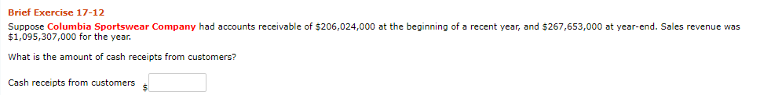
$ 1033678000
4.
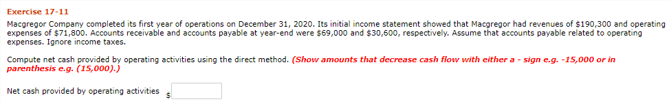
$ 87900
5.
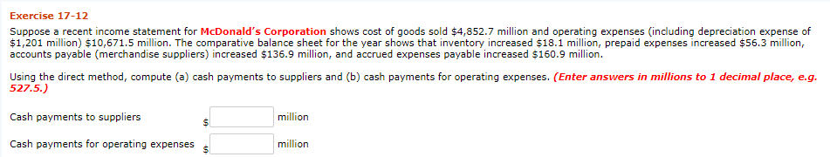
$ 5007.7
$ 10566.9

6.
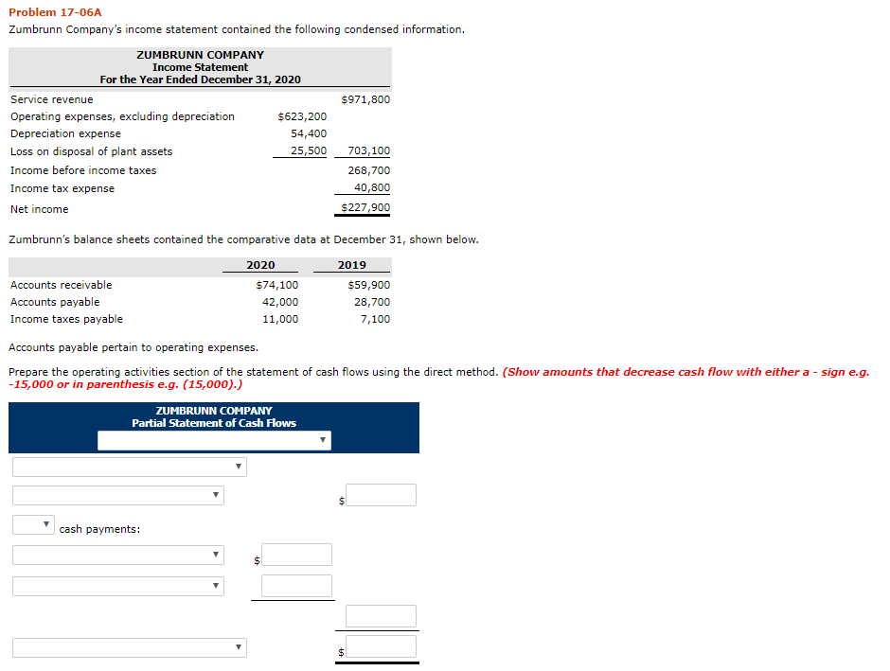
Cash received from customers |  |  |  | 971800
Operating Expenses |  |  |  | -623200
Income Tax Expense |  |  |  | -40800
Increase in payables |  |  |  | -14200
Net cash from operating Acts |  |  |  | 293600

