Black Holes
[Name of the Writer]
[Name of the Institution]

Black Holes

What is a black hole?
A black hole is a spot in space with very strong gravity. Not even a ray of light from sun or other stars can escape its gravitational pulling force. Its extremely strong gravitational pull is due to its huge quantity of mass concentrated into a very small space. The range of their within which they can even attract light is called Schwarzschild radius (Abdulkhalaq, 2013).

Size of Black Holes
The size of black holes varies from as tiny as an atom to as large as more than one million suns together. Even a tiny black hole has a very immense quantity of mass concentrated in very little area. Its mass can be as great as that of a mountain.
“Stellar” is the black hole with a mass up to twenty times more than suns mass. The scientists have predicted that in Milky Way, our galaxy, there are nearly one billion stellar mass black holes.
Yet larger in size are the “supermassive” black holes. Their mass may be nearly one million times more than the suns mass. Milky Way, the galaxy that carries our earth and solar system, consist of black hole of the supermassive category at its center, named by scientists as Sagittarius A. The mass of Sagittarius is equal to the mass of about 4 million. They exist at the center of all large galaxies observed so far by the scientists in the universe including the Milky Way galaxy of ours.

Formation of Black Holes
Scientists think that the formation of the smallest sized black holes dates back to as early as the beginning of the universe. However, stellar black holes, scientists have observed, are formed as in a process of the collapse of a very big star under its own gravity. The collapsed star is called a supernova. A supernova is an exploding star, a part of which blasts into space. About the supermassive black holes, the scientists think they were formed when the galaxies they exit in came into being.

Einstein’s Theory of Relativity and Formation of Black Holes
Einstein’s theory of general relativity predicted black holes. When a star dies, it leaves behind a relatively small remaining part, that has been called the core by scientists. The core's density is very high. Einstein's equation showed that if the core's mass is at least three times that of the sun, the gravitational force is so great that it results in the formation of a black hole (NASA, 2018).
Stellar black holes are formed as a result of star collapse. Even bigger holes are formed when stellar collisions occur. A black hole is also produced when a black hole and a neutron star collide. This collision results in a powerful explosion emitting gamma rays bursts (Sasso, 2012).
One explanation for the formation of supermassive black holes is that a chain reaction of stars collisions results in compact clusters, eventually becoming massive stars. These massive stars after collapsing under gravity form intermediate-mass black holes. A supermassive black hole is formed as these intermediate-mass black holes travel and are sunk towards the center of a galaxy. That is the reason why almost all the supermassive black holes are primarily found at the center of galaxies.

How do we know that the “invisible” black holes exist?
Black holes remain invisible to the eye because they pull all the light passing nearby them. Not even telescopes that detect electromagnetic radiations can directly observe them.
Their presence can be confirmed by studying their effect on stars in close proximity and gas surrounding them.
A black hole might be invisible itself, but light of very high energy is emitted when a black hole and an ordinary star some how come near to each other. The black hole strongly pulls with its gravity the star towards it center in a process called accretion. As the stars accelerate, it heats up and emits x-rays into space, which may be seen with the help of satellites and telescopes. For the observation of black holes, NASA's satellites equipped with telescopes travel in space.

Black Hole Image Makes History
A black hole and its shadow were very recently captured an image in a historic event.
Although a black hole cannot be seen, the ring of material that surrounds it shines bright. A black hole can cast a shadow against a bright background. The stunning picture actually shows the shadow of a black hole in the center of a galaxy called Messier 87, which is some 50 million lights years away from Earth.
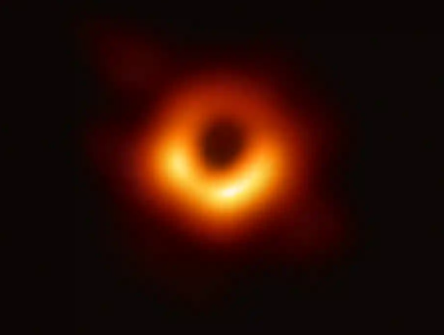
Figure 1: The event horizon at the black hole in galaxy Messier 87. Photograph: Event Horizon Telescope
The image was captured by a network of eight radio telescopes placed around the earth on its surface. This configuration enabled these telescope to work as if they were one telescope of the size of the earth (Elizabeth Landau, 2019).

Parts of Black Hole
Black holes consist of three main parts: singularity, interior space and event horizon. The black spherical surface of a black hole which has a high gravitational field is called event horizon. When a body falls into the event horizon, it travels through the interior space, reaching the center of the black hole called the singularity. Hawking believed the singularity is the part with the highest density.

Mysteries That Linger
It is appropriate to say that what we know about black holes is far less than what we do not know. It is yet to be known why particles experience a huge boost of energy near black holes, which results in fantastic emissions of rays. It is still not known where the energy goes when materials are sucked up by the black holes. Our lack of knowledge about black holes gives us a perspective on the immensity and complexity of the universe. It becomes a humbling experience. However, the recent feat of photographing a black hole also tells a story of our journey of exploring the enigmas of the universe and appreciating its grandeur.

References

Abdulkhalaq, H. A. (2013). Introduction to Black Holes.
Elizabeth Landau. (2019, April 10). California Institute of Technology. Retrieved from jpl.nasa.gov: https://www.jpl.nasa.gov/news/news.php?feature=7372
NASA. (2018). NASA Science. Retrieved from science.nasa.gov: https://science.nasa.gov/astrophysics/focus-areas/black-holes
Sasso, D. (2012, January). Relativistic Theory of Black Holes.

