[Name of the Writer]
[Name of Instructor]
Finance, Accounting and Banking
[Date]

Wk 1 Exxon Mobil

Company Name:
Exxon Mobil
Ticker Symbol:
NYSE: XOM
10-K Report:
https://ir.exxonmobil.com/static-files/37b7e1b7-620b-4248-a329-f2e152b4d7c3
Company Website:
http://corporate.exxonmobil.com
Company Business Model:
Exxon Mobile Corporation was incorporated in 1882 in the state of New Jersey. The corporation (Exxon Mobile) operates and market products to the market of United States and other international markets. The main business of the company and product line include the exploration and production of crude oil, gas (natural gas) as well as they are involved in manufacturing, transport, trade and sales of natural gas and crude oil, petro-mechanical, petroleum and wider variety of other specialty products on national and international level.
The key sources of company’s revenues are the earnings from manufacturing, trade, transportation and sales of natural gas and crude oil. The company also generates enough amounts of profits from the production and sale of petro-mechanical, petroleum and other specialty products. Sales and purchase of required goods and services in both national and international markets also contributes to the revenues of Exxon Mobile.
Exxon mobile has three main business segment which are, Upstream segment (Exploration, Development, and Production), Downstream (Transportation, Refining, and Marketing), and Chemical segment (Petro-chemical production and Technology Licensing).
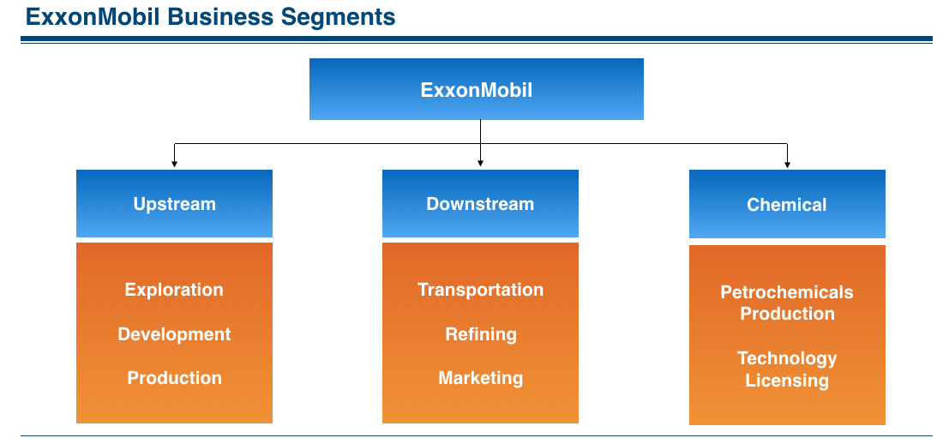
The main brand of Exxon Mobile are;
- Exxon
- Mobile
- Esso
- ExxonMobile Chemical

Stock Price Data:
5 Years Stock Price Graph
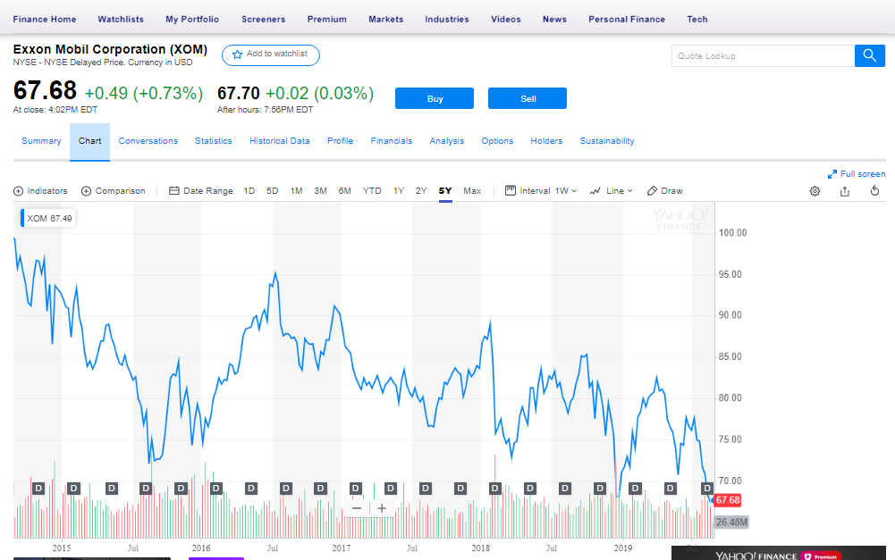

Stock Price Data (Highest Price Point in last 52 weeks)
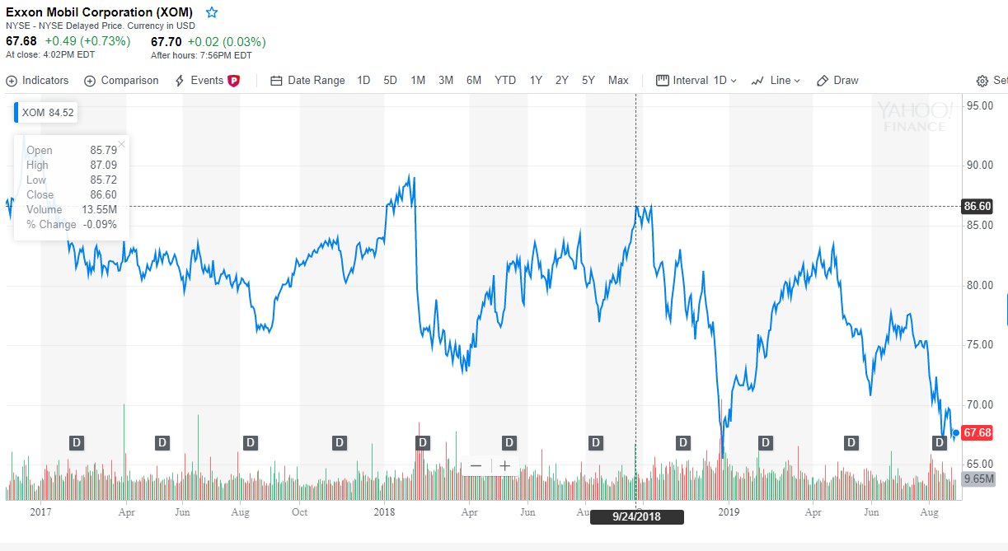

(Lowest Price Point in last 52 weeks)
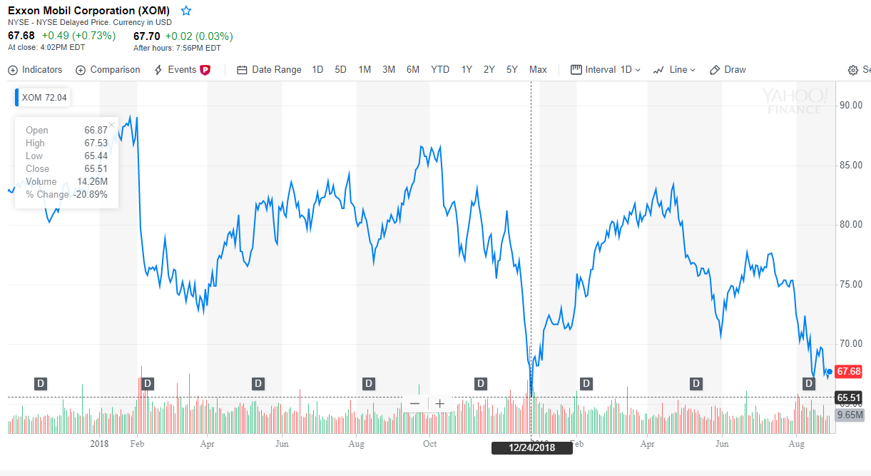
Evaluation
The stock price graph of Exxon Mobile does not seem fully stable all the time in last 5 years but looks positive and attractive. So it evidences the management’s ability that management would maximize shareholders wealth up to an impressive level. While I consider (my impression) performance of the company as positive.

Work Cited
Yahoo Finance. "Exxon Mobil Corporation (XOM) - NYSE - NYSE Delayed Price. Currency in USD: Yahoo Is Now Part Of Oath." Finance.yahoo.com. N. p., 2019. Web. 29 Aug. 2019.

