Student Name
Instructor Name
Course Number
Date
Post 2: Corporate Social Responsibility
Introduction
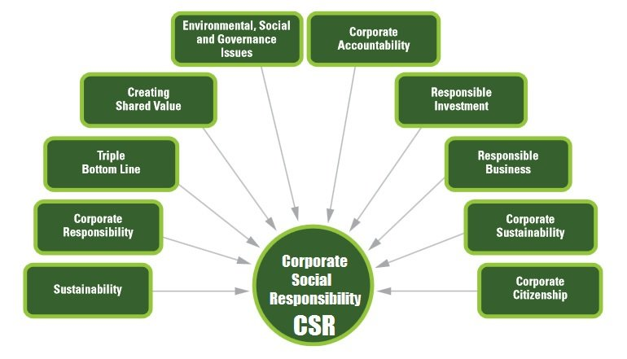
In the ever changing world, corporate social responsibility is an area which has received growing interest from both the academic and business worlds. The concept forces businesses to incorporate social, environmental, and health aspects into their policies. Another aspect of this concept requires that all the stakeholders should be considered while making any business decision. Traditionally, businesses cared for their profits and shareholders’ value while all other stakeholders were given secondary importance. The stakeholder concept was first introduced by Carroll who stated that a business has to fulfil the economic, legal, and ethical expectations of stakeholders in the society where it is serving (Tran).
Application
The Kellogg’s company has taken up corporate social responsibility by getting involved in school meals. This initiative was taken by company to make sure that no kid is hungry. There is a huge number of kids who are provided lunch in their schools and some of them are also offered breakfast. To enhance these efforts, Kellogg’s and ‘no kid hungry’ have joined hands to award $5000 grant to schools who find better ways to induce eating habits (Davidson). The company is also involved in a campaign to eradicate hunger from the world. The program is called ‘Better Days global signature cause platform’, targeting 3 billion people by the year 2030. Another aspect of social responsibility is a change in packaging strategy adopted by the company. The company aims at providing the best food to customers and working for a sustainable future for the whole society. An aim has been set by company to make sure that all materials used by company in packaging are 100% reusable by the end of 2025. 97 % of the content used in the company’s packaging comes from recycled or sustainable materials. This also includes the packaging used in Raisin Bran Crunch. More than 25 % of our plastic packaging content is also recyclable (Hughes).
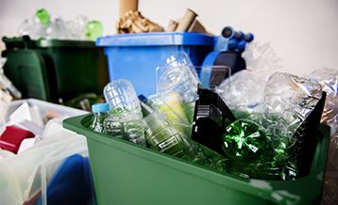

Works Cited:
Davidson, Wendy. "http://crreport.kelloggcompany.com/ElevateThePlate." 1 January 2020. http://crreport.kelloggcompany.com. 7 January 2020.
Hughes, Nigel. "http://crreport.kelloggcompany.com/sustainablepackaging19." 1 January 2020. http://crreport.kelloggcompany.com. 7 January 2020.
Tran, Ben. "https://www.igi-global.com/viewtitlesample.aspx?id=212116&ptid=206307&t=Corporate%20Social%20Responsibility&isxn=9781522573623." 2019. https://www.igi-global.com. 7 January 2020.

