Essay: Armenia Country Profile

Abdul

14November 2019

Physical geography of Armenia
Armenia is found in the South of Transcaucasia, this region is at Russian southwest between Caspian Sea and Black Sea. The present Armenia also have some parts of the historical Armenia which ancient center is at Aras River valley and across the Lake Van region in Turkey. In north Armenia is bordered with Georgia, on east with Azerbaijan, on southwest with Azerbaijan Republic, on west with Turkey and on South with Iran. Due to the geological upheaval the earth crust is pushed upwards and formed the Armenian Plateau which make the modern Armenian topography complex. The situated mountains made travelling difficult from north towards south. The continuous geological turmoil in the devastating earthquake form completely plagued Armenia. Armenia is situated at the Armenian mountains southern slopes at Lesser Caucasus. The highest peak of Armenia is 13,415ft or 4,090m and named as Mount Aragats while the deepest valley lie 1,200-1,870ft above the level of sea. The Akstafa River and the Debt valley create the major routes towards Armenia through North as it passes by mountains. Lake Sevan is 72.5km wide and 376km in length, it is the largest lake of east region. It is 2,070 m above the sea level. The terrain is mostly rugged at southeast region that is drained through Bargushat River as well as mostly moderate in the Valley of Aras River to southwest. Armenia is mostly drained through Aras and Razdan that flows from the Lake Sevan. Most of the Armenian border is with Turkey, Iran and the Nakhichevan that is bordered with Aras. Almost ½ of Armenian area is almost 29,800 km2 with 2000m elevation while 3%of the country is below 650m. The Armenian plateaus are masked through extinct volcanoes and intermediate ranges of mountain. The population of Armenia mostly lives in the country northwestern and western parts in which the two main cities Gyumri and Erevan are located. Generally the Armenia temperature is based on the elevation. The moderate climate influence the Black Sea and Mediterranean Sea developing the huge seasonal variations. Armenian Plateau, average temperature of mid-winter is 0ºC and the average mid-summer temperature is more than 25ºC.The mean precipitation is 250mm/year in the lower valley of Aras River to highest altitudes of 800mm. Despite the winter harshness in most of the parts the soil of volcanic plateau made Armenia a fertile land which can be used for agricultural activity.
Armenia environmental issues discussion is broad starting from mid of 1980s from the generation of intense air pollution through industry and nuclear plant and finally the Chernobyl reactor explosion. In the era of post-communist Armenia encounters huge cleanup of environment which confronts the previous Soviet republics that emerged through the system of centralized planning with resource management disastrous approach. The major environmental concern is the drop in the water level of Lake Sevan due to irrigation drawdowns and water diversion towards hydroelectric plants to the electric power compensation. It is reported by the Environment Ministry that the level of water is dropped by 50cm in 1993.
Linguistic Geography

Most of the population of Armenia is ethnically homogenous, Armenian nation mostly speaks Armenian as their first language. This is also the official language of the nation. Though the Russian language is introduced during the rule of Russia in Armenia and it is also widely spoken in the entire country. Whereas, English is also becoming popular as the foreign language while the minority communities also speak Greek, Assyrian, Russian and Yazidi which is spoken by respective country minority communities. According to the Armenia constitution, Armenian is the official language which is used widely by the country media and government. In the beginning of 19th century Russian Empire entered in Armenia and from then the Russian language become popular in the country. Though in 20th century only 3-4%population of Armenia can speak this language, although, during the rule of Communist they enforced Armenian people to use Russian language in administration, education and government that soon increased the number of Russian speakers in Armenia. In this time this language gained the second language status. Though the status and significance of Russian language is lost when in 1991 Armenia became independent. According to the report almost 70% of Armenian have basic Russian language knowledge while 52.7% population can speak Russian as second language. Almost 40% of the Armenian population has English language basic knowledge while only 4% have strong knowledge of English. Education in the English language is well promoted and accepted by the population of Armenia. Almost 33,509 Armenian citizen speaks Yezidi Kurdishas first language. In which 32,688 are ethnic Kurds while rest are non-Kurds.

Religious Geography

The Apostolic Church of Armenia is the Armenian national church and also 92.5% population of Armenia is associated with this church. According to Armenia constitution state and church are two separate units but on the same time the Apostolic church is considered as the Armenia national church that means this church has several privileges which are not provided to other churches. Though the religious freedom is guaranteed as the constitutional right however various people have filed religious oppression reports. Such reports range from difficulty in acquiring permission for construction to the verbal and physical harassment. From the total 3.1 million people of Armenia almost 98% have ethnicity with Armenian descent. Almost 92.5% of these individuals recognized as the Apostolic Church members although they are not the only religious identity of country. The other minority religions are Molokan, Orthodox Christians, Islam, Mormon, Protestants, Paganism, Yazidism and Judaism. Armenia became the world first nation who declared Christianity as their national religion in fourth century. With this faith practitioners celebrated Christmas on the 6th January combining the Epiphany feast and Jesus birth. The largest minority religion of Armenia is Yazidis who presented as the huge ethnic minority. The Yazidi religion is the combination of various religion which consist of Islam, Judaism, Christianity and Zoroastrianism. They came to Armenia from escaping the religious persecution of Sunni Kurds and Ottoman Turks from late 19th to early 20thcentury. Though these groups are now building the world huge temple in the Armenia. Now, the fastest growing religion of Armenia is Roman Catholic.
Population Geography
The total population of Armenia recorded in July, 1998 is almost 3,421,775, it is the smallest Eurasian country though its current population is 2.96 million which is estimated in 2019 which makes the population density of almost 256 people/sq. miles. In this way, this country population is ranked as 84th in the world. Almost 63% of Armenian population lives in the main metropolitan areas and the largest city is Yerevan which has the population of almost 1.075 million which is roughly estimated as 1/3 of the entire country population. It is the capital of country and is one of the oldest city of the world and is population is increasing continuously. Yervan is also the home of several major industries of the country and also have various international headquarters. The expectancy of life in Armenia is more than most of the other Soviet Republics with average life of men is almost 71.6 years while women are 78.3 years old. Armenian middle age is almost 35.6 years though this country population is largely dispersed in the world about 8 million Armenian are living in the entire world. The largest communities outside the Armenian country lives in Iran, Russia, US, Syria, Canada, France and Lebanon. As compared to the southern portion the country northern part is more densely populated. The yearly population growth rate in Armenia is near to zero from the start of this century. In the year 2019, this country population is standstill in growth on 0.09% per year. Also, the net migration to this country is extremely low though negative as well as the huge contributing factor to low population growth is child birth rate, which is 1.61 that is below-average and the lowest birth rate in comparison to the rest of the world. The lowest birth rate of Armenia was recorded in 1990s.
Political Geography
The Armenian Republic was independent from the year 1918 to 1921, although in 1921 this land was under the control of Soviet Union. Through the referendum of 21 September 1991 this nation became independent. In July 1995 the new constitution was approved as well as this constitution is revised two times both in November, 2005 and in 2015. In December, 2015 the constitutional reform occurred which made changes in the government system from the presidential system to the parliamentary system which was approved through referendum. The major political parties of Armenia are: Prosperous Armenia Party (PAP), My Step Alliance (which is based on Mission Part and Civil Contract), Armenian Revolution Federation (ARF or Dashnaksutiun), Bright Armenia and Armenia Republic Party (RPA). Currently the national assembly of Armenia have 105 deputies which are elected through the proportional system of two-tier. The candidates elected through the list of single national and the list of thirteen districts. In 2018 the presidential elections were conducted in March while the legislative elections were conducted in December. In reference to the constitutional changes, president is elected now through the parliament for the tenure of seven years. Prime minister is elected through the majority of the Parliamentarians. Prime minister as well as his cabinet should be approved through the vote of confidence given by parliament.
Economic Geography

After the independence, Armenia adopted the infeasible and unsustainable economy through the system of Soviet and then faced critical situations. Though Armenia is agricultural industry with various rich resources initially unable to utilize neither their fertile soil nor their rich natural resources. Without the resources of gas and oil Armenia encountered economic blockade since its independence due to its conflicts with Nagorno-Karabakh which separated it from Turkey and Azerbaijan. Though slowly and steadily Armenia boosted its economy in 1991 privatization begun in Armenia initially at the agriculture level then with the small as well as mid-sized business and in 1995 main businesses were privatized. In 1994, Armenia obtain funds from the World Bank and IMF this is the time when the national economy of Armenia is stabilized gradually. The GDP boost a little and the rate of inflation is also decreased. The current Armenia is agrarian-industrial country whose aim is to enhance agricultural production at small scale. The GDP of country is based 31.1% on agriculture, 21.8% on industrial production, 8.7% on trade, 8.5% on construction, 5.1% on transport and 24.9% on other sectors. The total agricultural land of Armenia is 44% of the total land. The most leading industries of Armenia are of metal working and mechanical engineering. In 1993 the ‘dram’ is introduced as the nation currency of Armenia. According to the report given by Armenia World Bank this country belongs to the middle income people.
Land use and Urban Geography

The total Armenia housing stock residential area is almost 95.024 million m2 in which 54.1% covered the urban housing. The entire accommodation number is 863,307 based on individual buildings and the buildings of multi-apartments, the 66% of which is in cities while 34% in the rural area. 92% houses in villages are based on the single-family system.

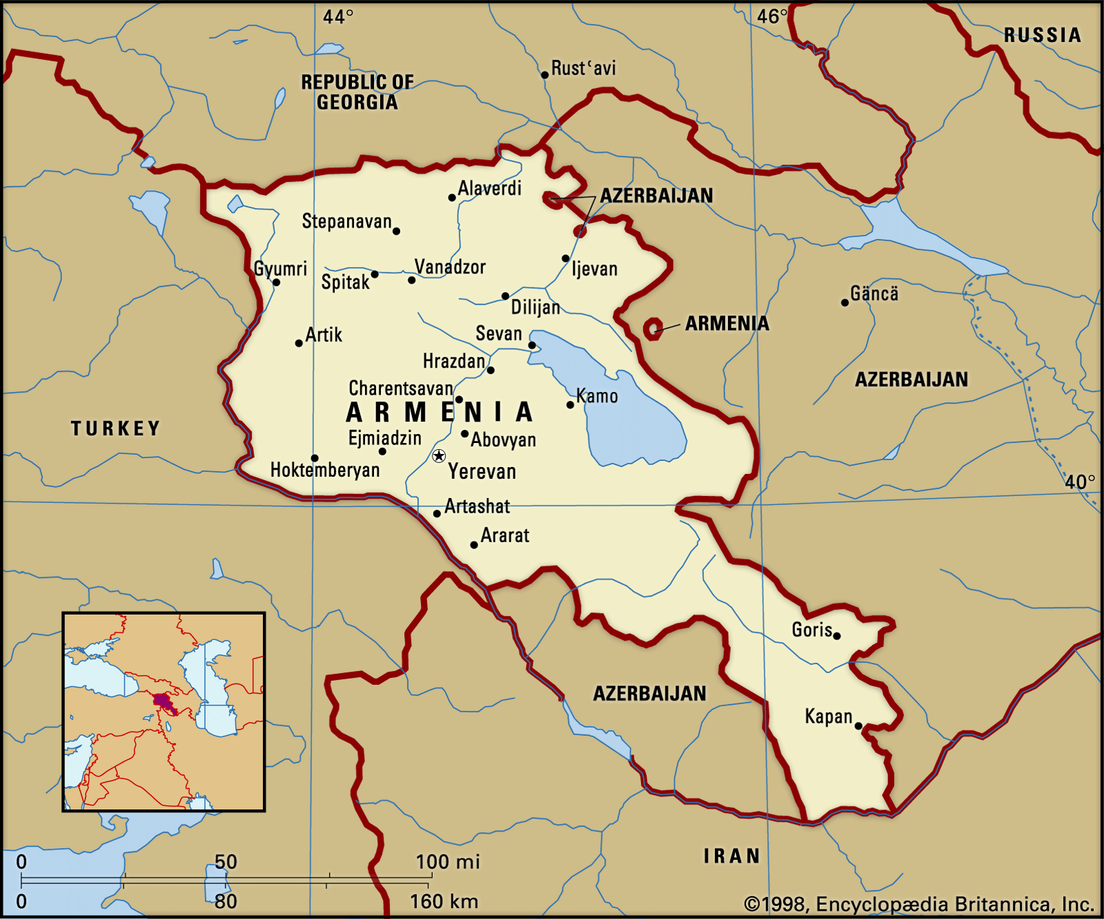
Figure 1: Map of Armenia with boundaries and cities location

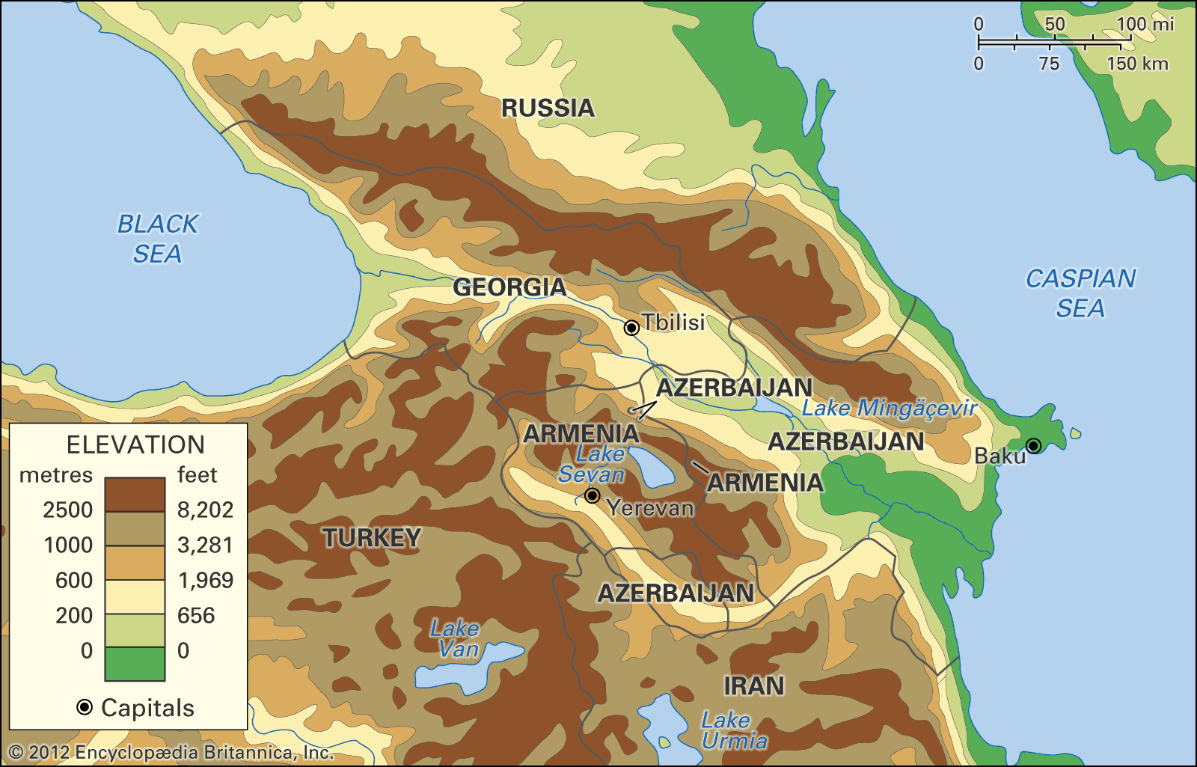
Figure 2: Map of Armenia identifying the elevations in country.

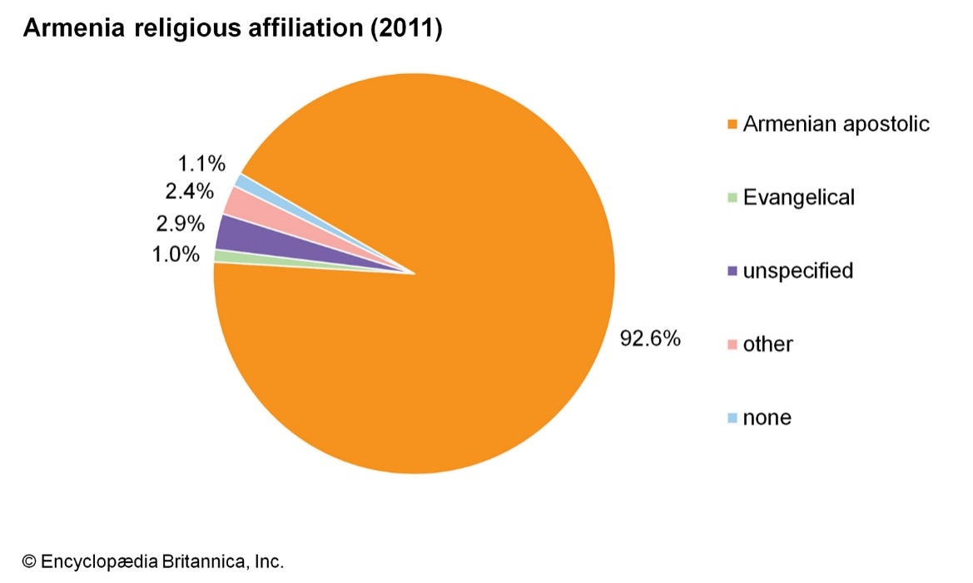
Figure 3: Chart of Armenia in relation to religious affiliation in country.

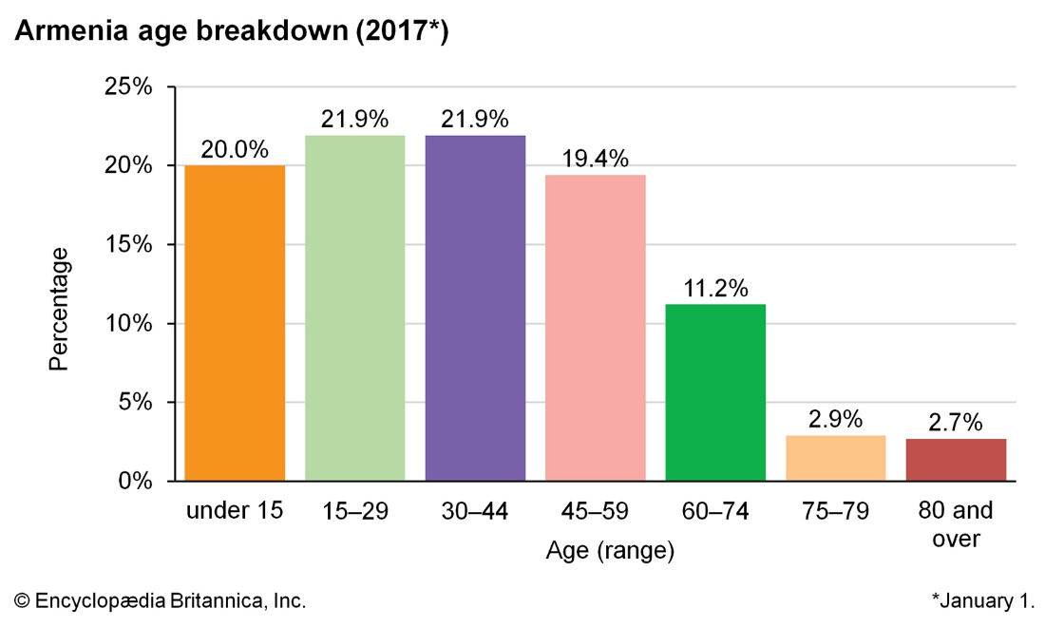
Figure 4: Graph of age break-down in Armenia

Bibliography
“Armenia | Geography & History | Britannica.” Accessed November 15, 2019. https://www.britannica.com/place/Armenia.
“Armenia Population 2019 (Demographics, Maps, Graphs).” Accessed November 15, 2019. http://worldpopulationreview.com/countries/armenia-population/.
“Economy of Armenia.” Accessed November 15, 2019. https://www.advantour.com/armenia/economy.htm.
“Political Structure.” Accessed November 15, 2019. https://country.eiu.com/article.aspx?articleid=517911635&Country=Armenia&topic=Summary&subtopic=Political+structure.
“Religion In Armenia - WorldAtlas.Com.” Accessed November 15, 2019. https://www.worldatlas.com/articles/religion-in-armenia.html.

“Armenia | Geography & History | Britannica.”
“Religion In Armenia - WorldAtlas.Com.”
“Armenia Population 2019 (Demographics, Maps, Graphs).”
“Political Structure.”
“Economy of Armenia.”

