35mm SLR Camera Usage
Student’s Name
Affiliations
35mm Film SLR Camera
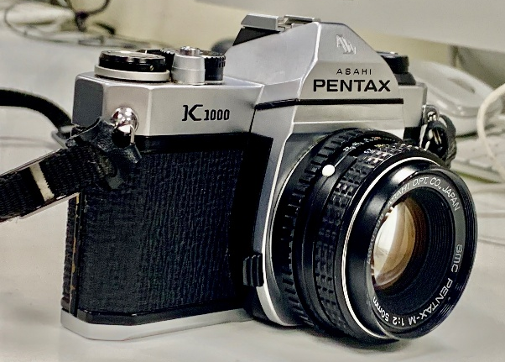
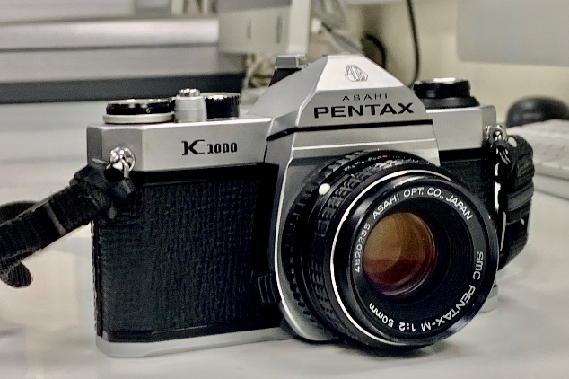

Question: What was one picture do you remember taking the most and why?
Answer: The one picture that I remember taking the most was a picture of a cave from outside within the Nottingham Castle. I remember taking that picture because it is a beautiful sight to visit and capture. The scenery for landscape photography is amazing.

Question: What shutter speed setting did you set to?
Answer: The shutter speed that I used most of the times was between 4, 2.8 and 2. The main purpose of this was to experiment with different type shutter speeds and then observing its effects on picture quality. I would often use this method specifically for the pictures of places I was the most interested in.

Question: What aperture did you set it up to?
Answer: For better sharpness depth of field and light an accurate aperture setting is necessary. Since it was a picture of a cave and there was relatively more darkness there I needed more light for my lens and hence a higher aperture was required. Therefore I used an F/4 aperture for my picture.

Question: How did you find focusing manually? Difficult or quite easy?
Answer: I found out that focusing manually is quite difficult because I haven’t used this type of Camera in a long time. Automatic usage of the camera is easy but the result is quite poorer as compared to manually operating your camera setting according to your requirement.

Question: Describe the experience of using a 35mm film?
Answer: The first time I started using the SLR camera, I found SLR quite difficult to operate. It was even difficult to put the film into the camera. However, after attending the lecture I started operating SLR camera and gradually got an idea about the camera and its settings. I am now getting used to its aperture settings, shutter speed and other basic requirements for photography.

Question: What do you differently that using this SLR to a Digital DSLR camera?
Answer: The first and foremost thing I would do is to get some background knowledge about the camera before using it. The DSLR cameras are quite common these days and people use them everywhere. Even if a person is not a professional but loves travelling, also have a DSLR camera in his possession. A DSLR camera is much easier to use due to its digital display and user-friendly interface.

