CIS 490: Project Deliverable 1 - Project Plan Inception
Student’s name
Institution
Date

Introduction
Masdai is Startup Company, which sells health equipment to customers. The company was established two years ago and due to high demand it has experienced high growth gain market share and high profitability as well. Masdai sells medical equipment online and it has stores where most of products are stored and sold. The company expects high growth within the next few years and therefore, it intends to install ICT infrastructure. It has ten employees working from its head office, and it is expected to experience steady growth within the next years to 30 years. It is established that Masdai revenue stands at $5 million and it is expected to grow to $30 within the next 2 years. The company therefore, requires the type of information system, which can support the current operation of the company and also scalable and expandable for future integration of other services and support the expansion as well. This is because Masdai is growing and it is projected that within the next five years, it would be one of the best and high profitable company providing medical equipments. The system therefore, must be prepared to accommodate future plans as well.
The ICT system to be implemented will integrate the operation of the company into a centralized database. The implementation of CRM, and management software integrated with the website of the company would be the best ICT system for the company. First, Masdai intend to sell products through its online product, and therefore, it needs CRM and a website to engage customers. The application of CRM and websites would allow customers to order for products online and also track the products until the delivery is made (Ahmad, 2018). The website is an interface where customer will use to communicate with customers and also make purchase. It is also important to point that the management software provides efficient management of finances and employees and therefore, it will contain the financial and human resource management for efficient operation of the company. The ICT system intends to include various services and sections, which are important for the operation of the company.
Databases
Database is essential for seamless flow of information and therefore, the database of the company would be integrated and connected with computers. The database will have layers to reflect the relation and most of the data will be stored in the server. The data will be financial, human resource, customers and there is a need for interlink or relationship which will be created so that it can operate seamlessly to improve the service delivery to customers (Sousa, Galante Porto, Takenouchi, & Marcatonio, 2015 ). The system will also be elaborate and including all the required ICT tools and therefore, the system to include CRM, management software, website and the entire infrastructure.
Security
The purpose of security is to protect assets and database of the company. With the growing technology and the involvement of different sectors such as e-commerce, personal computer, and internet, the concern about security is high. Most data are kept within remotely on the server and these data must be protected and the best way to offer protection to these data is by ensuring that the system is well setup and clear policies are also designed to protect the management of the network. Network security is therefore the most important component in the provision of security to the system (Kumar & Malhotra, 2015). It ensures that information which is stored cannot be accessed by any one. The network security will be implemented in there levels on the network infrastructure. It will be implemented at the backbone, servers, and at the computer. At the backbone level, the network security will be configured at router, gateway, and switches to prevent any unauthorized access to the network infrastructure and the database.
Two layers security system will be created at the router, switches and firewall. This is to ensure that the entry point to the system is protected and it becomes difficult to gain entry into the system and database (Ahmad, 2018). The switches also will be configured with strong passwords or key to prevent any entry and therefore, installation of network security is necessary and it will be done at the entry point to ensure that the system is protected. Besides installation of security at the gateway and switches, strong firewall hardware will be included among the security setup as indicated on the diagram 1 below. It will limit access to the system to ensure that unauthorized person does not get access to the network. In some cases, the security is also deployed at the gateway to ensure that the system is fully protected. However, it would be important to ensure that there is a clear security policy, to prevent the data from being accessed.
Networking
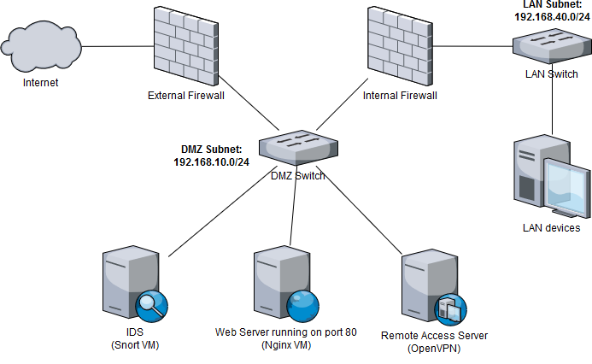
Diagram 1: Masdai’s ICT Infrastructure
Computer infrastructure
As illustrated in the diagram 1 above, the company to have several ports for computer connection. The workstations will be connected to the server where the management software and other software are installed and integrated for efficient operation. The computers will be arranged in parallel with each workstation have password. The system will be set to accommodate more workstations in the future (Ahmed, Bwisa, & Karanja, 2018). The computer infrastructure will include desktop, server, router, gateway, and firewall foe protection.
Human computer interaction
Masdai will develop an interface to make it easy for clients to access its services.
Web design
The company will have a well developed website. The web site will be integrated with the CRM and management system for customers to be able to access the services of the company efficiently. Since the company intends to sell its products through online platform, the website should be interactive and therefore it will be integrated with the company’s system, CRM and management system. But it will be hosted by the company since it intends to have a web server.

References
Ahmad, N. (2018). Analysis of Network Security Threats and Vulnerabilities by Development & Implementation of. 2-31.
King, T. (2014). CompTIA Security+ Exam: Devices, Media, and Topology Security. 2-3.
Kumar, A., & Malhotra, S. (2015). Network Security Threats and Protection Models. Technical Report – CSE-101507 , 2-34.
Ossi, V. (2018). 2 EVALUATION OF FIREWALLS AND RESEARCH. Degree Programme in Information Technology , 5-38.
Salah, A. (2018). Design and Implementation of a Network Security Model for Cooperative Network. https://www.researchgate.net/publication/50367393_Design_and_Implementation_of_a_Network_Security_Model_for_Cooperative_Network , 2-35.

