Introduction to Health Informatics
Submitted to
Affiliation
Date

Uniform Hospital Discharge Data Set (UHDDS) for inpatients
According to the definition of the main diagnosis of the Uniform Hospital Discharge Data Set (UHDDS): " After the trial, it was determined to be the main cause of the patient's hospitalization."
Diagnostic definition:
According to the Uniform Hospital Discharge Data Set (UHDDS), the additional diagnosis is defined as: " Any condition that occurs when a patient is admitted to the hospital, which may affect the patient's treatment or hospitalization days as the disease progresses. " If the condition is unrelated to the previous diagnosis and is not related to this hospitalization, it cannot be regarded as an additional diagnosis.
Compliance with secondary diagnostic conditions refers to conditions that affect patient care, such as Clinical Evaluation, Therapeutic Treatment, Diagnostic Procedures, and extended hospital stays (Extended Length of Hospital Stay) Increased Nursing Care and/or Monitoring. (Mon, 2015). The discharge diagnosis listed in the medical record summary or the home page should be coded; however, some cases are not relieved or are performed for the previous admission and are not related to this hospitalization.
Condition or a family history of past influence the present tense of care or treatment, the associated history of the code shall be compiled for the secondary diagnosis. Unless the physician expresses Abnormal Findings clinically significant (e.g. laboratory tests, X-rays, pathology, and other diagnostic findings), no coding is required; if abnormalities are found to be outside the normal range, and the attending physician opens additional tests When assessing or following treatment, ask your physician if patient want to increase the diagnosis for this abnormality. If the diagnosis described in the discharge record is Probable, Likely, Possible, Suspected, Questionable, or Still to be Ruled Out, it should be coded if the diagnosis exists or is confirmed.
From the very beginning of treatment, a plan for discharge or a possible transfer to another hospital for further treatment begins. If you, as a patient or a loved one, have any comments to be discharged or further treatment that need to be taken into account, inform the nurse in charge or the doctor, the nursing staff in advance of discharge. At discharge from the hospital, the patient is issued; (Seavey, Aytur & McGrath, 2014).
- Required prescriptions or prescription information for e-prescription drugs
- The sick-list and other necessary certificates, such as a certificate for monetary reimbursement of travel expenses. Tell staff what you need before you leave.
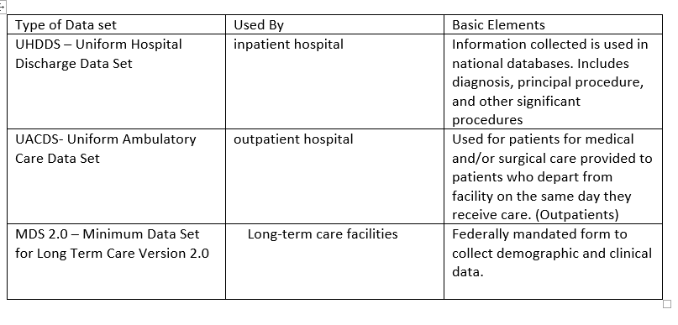

Uniform Ambulatory Care Data Set (UACDS) for outpatient or ambulatory patients
Outpatient health activities are carried out in the usual living environment of patients: outpatient health professionals travel to and from the home or place of residence or receive patients on their premises. According to Mohlenbrock & Breen, data set ensure the link between residential care and living space and vice versa, respecting the principle of continuity of care. Accompanying patients in their living environment is the essential element of ambulatory health. (Mohlenbrock & Breen, 2014). Formed data sets are entered into a database containing information about patients of a medical institution. Access to the database is provided by the database management server of the medical institution. Form an archive of data describing the state of health of the patient of the medical institution. For each patient of the medical institution, additional medical institutions where the patient is registered are questioned. Receive the last data in time characterizing a state of health of the patient. Form the third access code. Moreover, the third access code together with the first access code identifies a part of the formed set of patient data of a medical institution. And the third access code together with the second access code gives the right of access to a part of the data set of patients of a medical institution. The method allows to increase efficiency by automating the provision of relevant data to the user, depending on his authority with access to a part of the patient’s data of a medical institution, as well as providing simultaneous access for an unlimited number of users.

Minimum Data Set (MDS) for long-term care
This improvement in MDS data set ensures that all individuals will be able to state their preferences and will be able to get acquainted with the accommodation options in own house. MDS 2.0 Dataset Guide for Instructors (Instructors Guide) provides guidance for nursing care facilities regarding their actions in case of an affirmative answer with the parties of the lodger to put into action the planning follow-up care and contact your local man agency for a guest request within 10 business days from receiving an affirmative answer. However, these guidelines are a recommendation, not a requirement. Follow-up is expected within a "reasonable" term.

References
Mon, D. T. (2015). Development of a National Health Data Stewardship Entity Response to
Request for Information.
Mohlenbrock, W. C., & Breen, T. M. (2014). U.S. Patent No. 8,762,169. Washington, DC: U.S.
Patent and Trademark Office.
Seavey, J. W., Aytur, S. A., & McGrath, R. J. (2014). Health Policy Analysis. Springer
Company.

