Fact Sheet
Submitted by

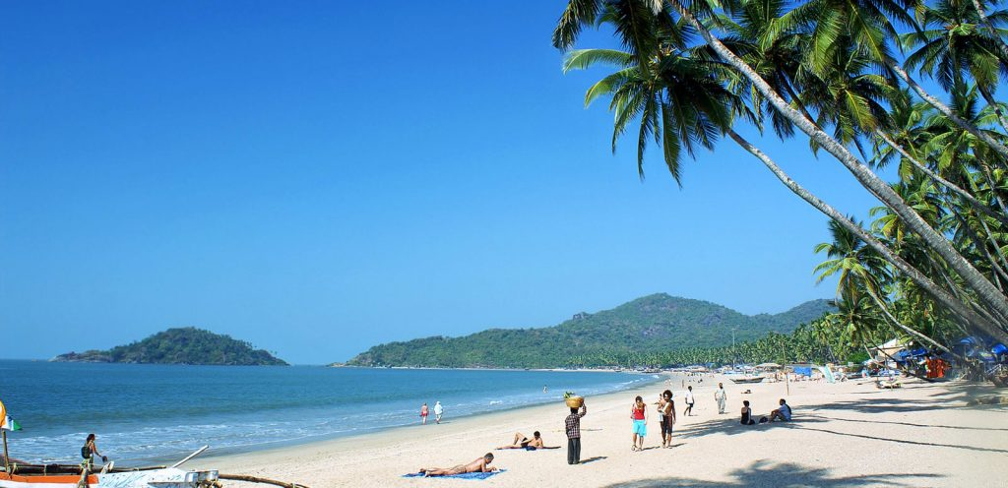

College / subject
Date

GOA-India
The Indian state of Goa, more than half of the foreign tourist flow to which falls on Russia, is still behind in popularity from other mass winter destinations. Prices for destinations increased by 22% over the year, but leading players still maintain their flight programs at last year's level. Goa is consist of 105 km of coastline with beautiful beaches of Asia. Goa beaches is most visited place both by foreign and domestic tourist every year. Many of the beaches are lively and loaded with every kind of facility for tourists. Tourist came from all over the world and almost every month all round year
History of Goa
The history of Goa is very old. The colonialists titled it as the capital of India. They recognized the beauty and structure of Goa thought its natural beauty and building structures. By that time, the history of India equaled approximately 4 thousand years. Goa was a tourist place in past and still, it is one of the most visited places in India.
Number of foreign and domestic tourist
According to Economic times if India, 8.9 million foreign tourists visited India in 2016, up 11 per cent from the previous year. Goa, the state which was previously a Portuguese colony, is recognized for its beaches, and one of the most prevalent traveler destinations for both Indians and foreigners similar. The domestic tourists in 2017 was about five million, with half a million foreigners.(Statista) . The below graph presents the statistical comparison from 2012 – 2018 of both domestic and foreigners who visited Goa.

Role of Tourism in Indian GDP
Access to tourism in developing countries and especially in countries Emerging Asia is a notable reality still poorly known and insufficiently considered by tourism research. Yet the flows that this domestic tourism mobilizes are considerable. In India, the middle classes resulting from the liberalization movement of the economy of the early 1980s constitute the bulk of the tourist troops and exceed very largely the flows of international tourism. Linked to the global diffusion of tourism practices invented in the West, the practices of Indian tourists are not yet not mere reproduction. It is the same for tourist places that they frequent and produce, and which are not practiced according to the same modalities.
Understand the practices of these tourists and their places of predilection is therefore an important issue socio-economically and scientifically in relation to the question of dissemination of tourism practices in different socio-cultural contexts and the understanding of the process of globalization. These are the questions that we propose to ask this communication through the practices and places of domestic tourism and tourism in India.

In 2017, India evaded France and came at the 6th place according to the countries in terms of GDP. According to experts India tourism will be the at the third place in Asia and will be largest economies of world. However, the high rate of social inequality and the lack of qualified employees continue the main challenges for Government to invest in tourism industry. How the “Indian miracle” can change the modern way of life in the global economy is a main thing to consider. India’s GDP in April-June grew by 8.2% compared to the same period last year. The indicator strengthened India's position as the fastest growing among major economies. The growth rate was highest from January-March 2016, when a rise of 9.3% was recorded.
Analysts surveyed by Bloomberg on average predicted a country's GDP growth of 7.6% last quarter. In January-March, GDP grew by 7.7%. Gross value added in April-June increased by 8%, while growth of 7.5% was expected. Production in the manufacturing industry increased by 13.5%. In agriculture, an increase of 5.3% was recorded.
Main Attractions of Goa
The main attractions of Candolim in Goa are the golden sand beach and Aguada Fort, located next door. Near the beach there are many decent cafes and restaurants, there are bars and necks. In the menu of establishments you can find both local and European dishes. Waves in this part of Goa are extremely rare, so Candolim has become a favorite vacation spot for older people and families with children from Europe. Also, wealthy Indians often come here.
Goa is the main resort of India, as it often happens, completely unlike the rest of India. The coast line goes around 110 km, forming 40 beautiful beaches. The state of Goa is divided into two parts the south and north with the border separating both parts. Goa goes largely for beach vacations and Ayurveda. Mostly tourist came here to visit city and for the medical purposes. Goa's excursion program is not rich, Dudhsagar Falls, the village of Hampi with a bunch of ancient ruins are interesting from local attractions, and boat trips and fishing are popular for outdoor activities.
Hotels and guest houses located in South Goa are considered expensive, and not only by Indian standards. They are popular among wealthy Europeans and wealthy Indians. The exact opposite to the North Goa , relatively inexpensive, noisy and democratic - in the 60s. This place was chosen by hippies, and so they stayed there. Today, in the numerous villages of North Goa, mostly party-goers from America and Europe settle, thanks to which these lands became famous all over the world.
Bibliography
Borges, C.J., Pereira, O.G. and Stubbe, H. eds., 2000. Goa and Portugal: history and development (No. 10). Concept Publishing Company.
Chowdhary,Adit . 8.9 million foreign tourists visited India last year, up 11% from 2015. economictimes.indiatimes.com/articleshow/57296453.cms?from=mdr&utm_source=contentofinterest&utm_medium=text&utm_campaign=cppst//economictimes.indiatimes.com/articleshow/57296453.cms?from=mdr&utm_source=contentofinterest&utm_medium=text&utm_campaign=cppst
Foreign and domestic tourist arrivals across Goa in India between 2010 and 2017.https://www.statista.com/statistics/1027205/india-tourist-arrivals-in-goa-by-type/

Borges, Pereira and Stubbe, 2000
statista.com
Chowdhary.,1
Chowdhary.,1

