Compare and contrast Shosoin Tang box
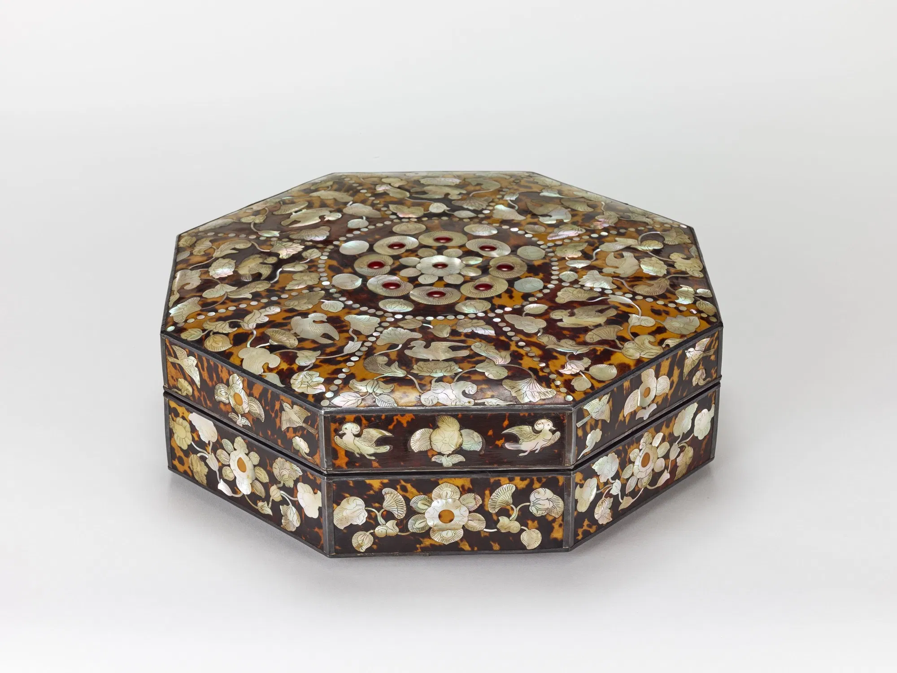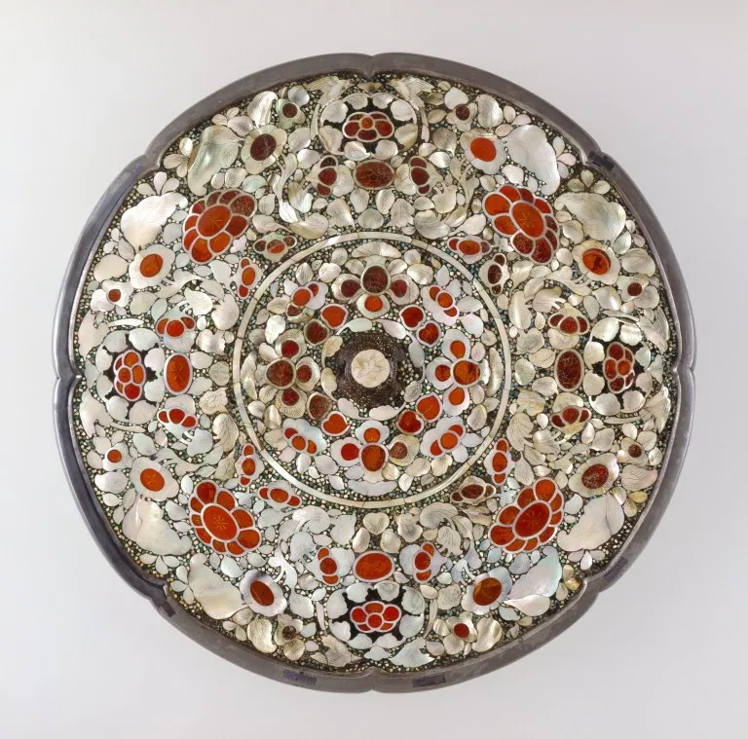

These Shosoin tang Design box was a repository of the Todaiji Temple. Both boxes are very similar and there are some contrast as well. In particular, the Raid Box is an approach to beauty that is different from the Tang people, and the technique of making the decorations blackish and contrasting the brightness is rather effective with a modest decoration. It is worth admiring that this technique has created a bewitching beauty that is not inferior to that of Tang and has made it more Japanese and Western.
Color :The color of both repositories are bright. Usually combination of red , white. Raden is processed into wood, glazed, lacquered, resinous, etc. In addition to shellfish, cocoons, turquoise, and blue gold stones are used as materials, making full use of the best technologies and designs of the 8th century.
Shape & Design: one is in plate deep shape and other is diagonal box. The treasure gives Tang people a sense of superiority, while other countries absorb the continental culture, while concentrating on different materials in limited materials and feeling the Japanese attitude to pursue their own culture.
Shosoin treasures are categorized into those produced in the West and transmitted through the Silk Road, those produced and produced in Tang and Silla, and those produced in Japan. And this characteristic of Tenpyo culture has also appeared in the design of treasures. Until this time, Japan acquired styles and techniques through imitation, and gradually began to make it uniform. The Taiho rituals are the indigo books of the Tang dynasty rituals and the eternal rituals. Then, here, Raden Dan Gogen Biwa, which is transmitted as a Tang-made product, an Octagonal box, which is transmitted as a product made in Tang, and a Japanese-made product, Kasou Hosen-Dragon Tank, which is transmitted as a product made in Japan. Zomela Densobi, Radenbako, and specifically compare Raden crafts.

References
Inokuchi, H. (2009). Shōsōin: The Oldest Archive in Japan. Library & archival security, 22(1), 61-70.
Rawson, J. (1982). The Ornament on Chinese Silver of the Tang Dynasty (AD 618-906) (No. 40). British Museum Publications Limited.

