Your Name
Instructor Name
Course Number
Date

Title: Put First Things First
The 7 Habits of Highly Effective People is a masterpiece by Dr. Stephen Covey, and this book is the best seller for so many reasons. This book is based on the idea that effectiveness does not come from tools and systems, but it is something that comes from within. Covey did not invent the habits; he went through the success literature and summed up them in a sequential flow of 7 habits. Employing and living these habits in one's life helps one to become more effective. These habits assure one's growth in maturity in three levels, from dependence to independence to interdependence (Covey). It is not wrong to declare this book the Bible of productivity. This report is based on the third habit from seven habits, but first things first based on the principles of personal management.
This habit is focused on prioritizing tasks and putting the most important tasks on first and doing the most important things on priority. It is very easy to fall in the trap of procrastination and distraction of non-important things. In this habit of self- management Covey guides, how to become master of our time. For this purpose, the first thing a person must know is to know about their priorities in life. According to Covey, the first three generations of time management are taking notes, using calendars and checklists, and the third is about planning and prioritizing. The fourth generation, Time Management Matrix, developed by Covey, helps one to map their daily life activities and brings clarity in one's time allocation choices. This tool is focused on results that contribute to the attainment of one's goals and objectives. This matrix has four quadrants, wherein everyday activities can be divided into each quadrant.
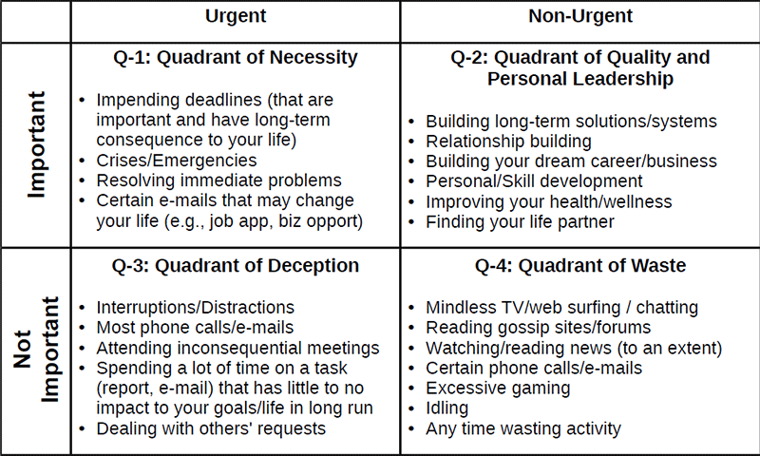
The first quadrant deals with important and urgent activities. It has all the emergencies and crisis, and all the tasks that scream one's attention. It is also referred to as Quadrant of Necessity. The second quadrant is where the magic lies; it is the quadrant of personal leadership and quality. All have all the tasks that are not urgent, but they are significant such as building relationships, nurturing health and activities, writing the personal mission statement, and focusing on one's vision. The activities in this quadrant reap the most reward at the end of the day. It is all about sowing seeds for one’s future.
The third one is the quadrant of deception; it has all the tasks and activities, which are just urgent but not important. People who spend most of the time in this quadrant end up packing for unimportant things. The last quadrant contains all the activities that are mere time wasters. All the activities that are neither important nor urgent. Tasks in this section bring no benefit and create no value; rather, it results in irresponsible behavior. In order to be effective, one needs to change their behavior in these ways consciously. Managing the tasks in the Q1 to get them out the way and focusing on the Q2 tasks, delegating tasks of Q3 to others with minimal involvement, and dump all the tasks in Q4.
I believe that student life is the right time to implement this habit; this is the right time to set goals, personal mission, and vision and focus on personal leadership. Setting life on track at this time will reap the rewards forever. We need to focus on our main goals in life or tasks at work by taking advantage of those distractions. There are internal forces and external forces in our lives every day. The best method to use if you are constantly distracted in life is to use lateral thinking styles. I believe a creative mind does more than an analytical mind. After I read the book, I realized the significance of fourth-generation time management tool, I made a quick analysis of my activities and realized how far I am from panning and setting goals on what is most important in my life. My focus for the current year is to start working on Q2 tasks alongside eradicating Q4 activities. I believe this habit plays an imperative life in academic life where it is very easy to get distracted by external factors.
The important thing for us is to know what matters most in our life to set our priorities. My initiative to implement this habit acquainted me with the fact that everything takes time, in order to adopt new habits, you must give yourself a time to learn and adopt good habits. Nothing happens without one’s desire, willingness to sacrifice for what they want. It is true that luck happens when preparation meets the opportunity. I believe this is an excellent book, and its seven principles, if followed, will make one more effective no matter what they do. It is one of those books that not only forces one to think but to create themselves. Steven covey very intelligently leads the reader to analyze yourself in a way most suitable for you. This one single book contains everything one needs to manage effectively. One of these habits discussed is the most effective in making most of one's time if followed as instructed by Covey. This habit of time management can be summed up in this quote him, "The key is not to prioritize what's on your schedule but to schedule your priorities.” (Covey)

Works Cited
Covey, Stephen R. The 7 Habits of Highly Effective People: Powerful Lessons in Personal Change. Simon and Schuster, 2004.

