Blog
Your Name (First M. Last)
School or Institution Name (University at Place or Town, State)

Marketing concepts, customer’s needs and change over time
In today’s world, most of the people are much familiar with the term “Market”. It means a place where buyers and sellers meet each and exchange takes place. Every field has its market and by taking a look at the history of the market, it could be witnessed that marketing concepts went through many changes with time. Field of marketing changed quickly as grabbing the attention of the audience has become a difficult task. It has been seen that diversity in variety and different marketing strategies have been fueled with the advancement of time.
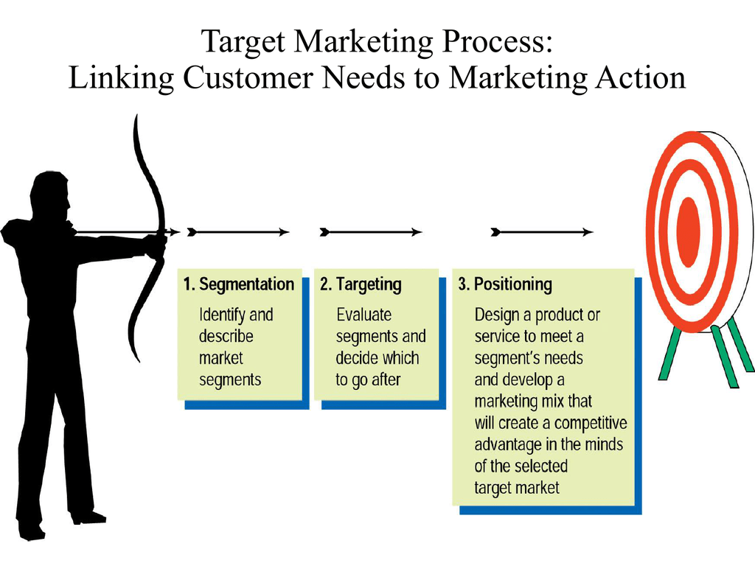
Though, a revolution in the marketing concepts has been witnessed and there are some key elements in marketing field that are still focused i.e. human activity, customer satisfaction, needs and wants consideration and exchange processes. Marketing concepts are designed by taking into consideration the products and demands of the customers. For example, if a clothing company wants to do marketing of its brand then marketing strategies would be planned by keeping the trends and needs of customers in mind (Armstrong,et,al,2018). Marketing concepts are based on a few basic principles. First of all, the marketing concept focuses on attracting the target customer. When targeted customers are attracted and a brand or company gets considerable consumers for its products than retaining customers could be looked upon as the next greater challenge. Retaining customer is a tough task particularly when customers have a range of variety being offered by other organizations or companies in the same market. By giving priority to the customer needs and considering their satisfaction at first place, companies aim at converting first-time costumers into repeat customers. Marketing strategies and a brand would become successful only when customer needs are given topmost priority. Building a satisfactory relationship matters a lot for promoting mutual understanding between the customers and staff (company’s staff).
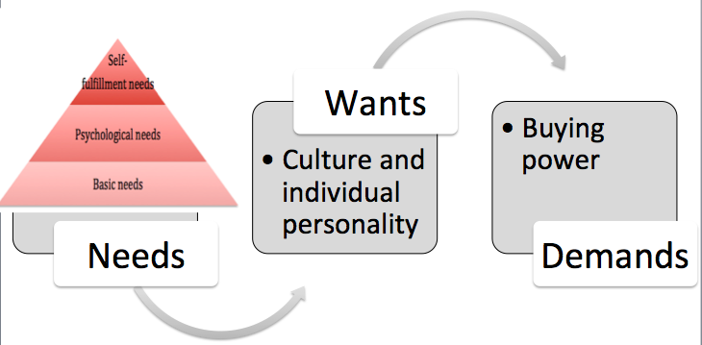
Undoubtedly, needs of the customers changed with time. Customer needs got a central place in marketing. Only those brands or organizations secure the best place in the market that best meet their customer's needs. It is the psychological makeup of the customers that plays a vital role in developing a product as well as the marketing strategies are being made as per the mentality of customers, so that the needs of customers could be fulfilled (Kasemsap,et,al,2018). Customer needs are not only important during the time of making products and promotion rather customer considerations are also of great importance after a product is marketed as if customers would become happy with product or service, more customers would be there. It has generally been seen that only those companies survive in the marketplace that satisfy customer needs. Marketing is done by companies for making the customers aware of the products and services being provided by a them.
It is a common observation that both needs and marketing strategies changed with time. For example, when customers in 1950s, become aware of health issues with sugar, there was witnessed an increase in the demand for diet soda as compared to the regular drinks. Likewise needs as well as marketing messages changed over time. At present, not only products are made by keeping an eye on the needs of consumers but at the same time, marketing strategy would be planned as per the customer’s demands. An organization used to make superhero costumes for children; initially, it was going very well but when it stopped taking in considering the preference of customers and failed to meet customer’s needs it was no more in the race of top brands. So as a whole, it could be said that marketing is dependent on the type of the customers and their needs i.e. marketing strategies and promotional concepts should be in accordance with the customer’s taste (Micheaux,et,al,2019). Nowadays, social media is one of the best sources used for advertisement and companies used to design their websites in such a way that they would grasp the attention of the target customers. Websites and company pages are designed by implementing those marketing concepts that would fit in with the customer’s needs.
References
Armstrong, G. M., Kotler, P., Harker, M. J., & Brennan, R. (2018). Marketing: an introduction. Pearson UK.
Kasemsap, K. (2018). The roles of corporate marketing strategies and brand management in the global retail industry. In Digital Marketing and Consumer Engagement: Concepts, Methodologies, Tools, and Applications (pp. 294-325). IGI Global.
Micheaux, A., & Bosio, B. (2019). Customer journey mapping as a new way to teach data-driven marketing as a service. Journal of Marketing Education, 41(2), 127-140.

